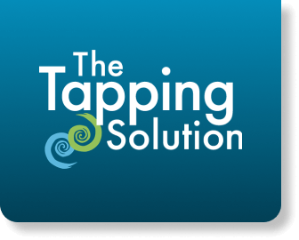
Tapping Solution, LLC. Call for Proposals Application
Please submit this application—along with a Biosketch, CV, or Resume for the Principal Investigator (and any Co-Investigators)—by June 30, 2024 to:
drmelaniegold@gmail.com and nickortner@gmail.com

PROPOSAL TITLE | Click or tap here to enter text.
ABSTRACT/SUMMARY (up to 30 lines)
Click or tap here to enter text.
SPECIFIC AIMS (1 page maximum)
Click or tap here to enter text.
RESEARCH STRATEGY (3 pages maximum) to include:
Background/Significance – What is the issue, condition, or problem? Who are the individuals affected? What benefit could a self-guided Tapping app achieve?
Click or tap here to enter text.
Setting/Population – What is the project location, target audience, and target issue? That is: what setting, what patient/client population, and what symptom/condition to address with tapping)
Click or tap here to enter text.
Approach/Methods, including outcome metrics (e.g., scores on surveys) and process metrics (e.g., # participants using app), a description of processes to handle user data, and how to protect confidentiality.
Click or tap here to enter text.

ADVANCEMENT OF SCIENCE STATEMENT (maximum 200 words)
Describe how proposal will advance the evidence base for the Tapping Solution App and future plans if application is chosen (ma
Click or tap here to enter text.
Principal Investigator |  | Click or tap here to enter text. | Email | Click or tap here to enter text.
Primary Contact |  | Click or tap here to enter text. | Email | Click or tap here to enter text.

